**Chapter 1 - ANIMAL RIGHTS IN ISLAМ: SHOWING COMPASSION**

**All Lectures Uploaded on YouTube:** [**https://tinyurl.com/fkm10-english**](https://tinyurl.com/fkm9-english)

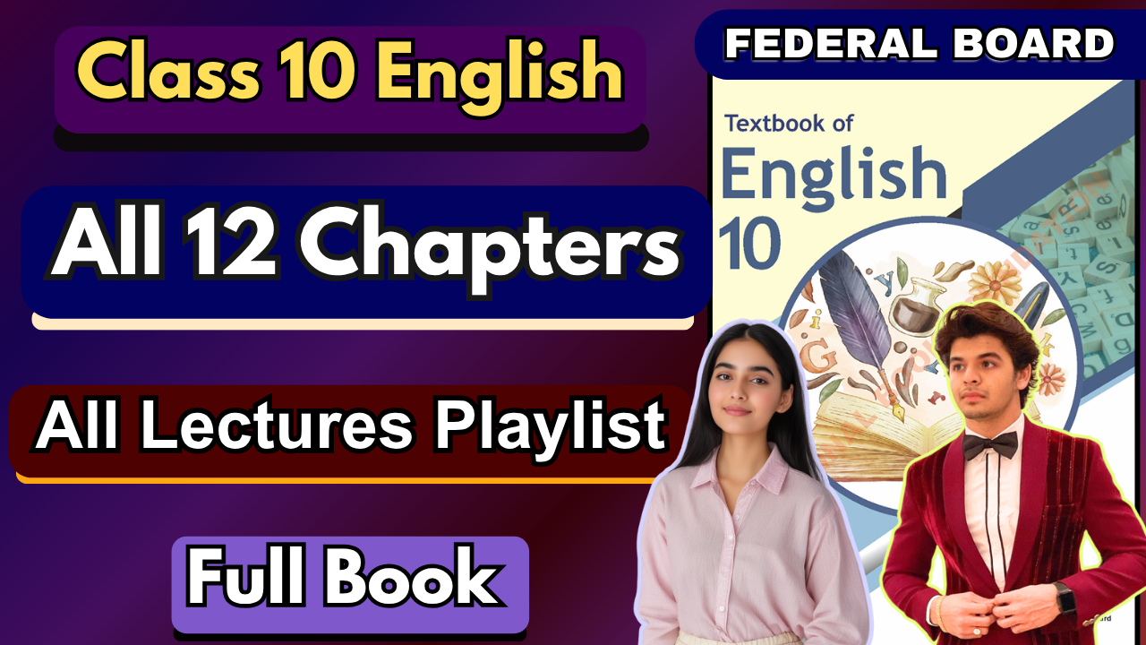

**Glossary:**

**Given below are the difficult words from the unit. Look at their meanings and use these words in your own sentences.**

| **Words** | **Meaning** |
| --- | --- |
| sentient | able to perceive or feel things. |
| intricately | in a very detailed or complicated manner. |
| coexistence | the action or condition of living together in harmony. |
| imperative | of vital importance; crucial. |
| exploitation | the action or fact of treating someone unfairly in order to benefit from their work. |
| inextricably | in a way that is impossible to disentangle or separate. |
| staunch | loyal and committed in attitude. |
| prevalent | widespread in a particular area at a particular time. |
| advent | the arrival of a notable person or thing. |
| stewardship | the responsible planning and management of resources. |

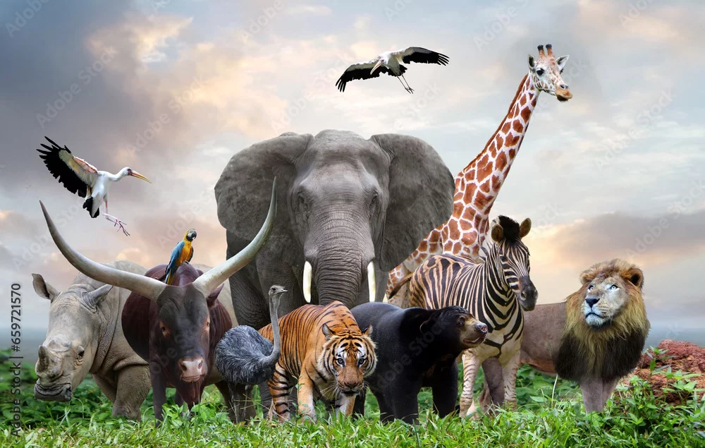

**Ans. Here are sentences using each word in a clear and meaningful way:**

1. **Sentient** – Scientists continue to debate whether artificial intelligence could ever become truly **sentient**.
2. **Intricately** – The walls of the ancient palace were **intricately** carved with floral patterns.
3. **Coexistence** – Peaceful **coexistence** between diverse communities is essential for social harmony.
4. **Imperative** – It is **imperative** that we address climate change before it becomes irreversible.
5. **Exploitation** – The **exploitation** of natural resources has led to severe environmental degradation.
6. **Inextricably** – Human progress is **inextricably** linked to advancements in science and technology.
7. **Staunch** – She is a **staunch** supporter of human rights and advocates tirelessly for justice.
8. **Prevalent** – Malnutrition is still **prevalent** in many underdeveloped regions of the world.
9. **Advent** – The **advent** of the internet transformed the way people communicate and learn.
10. **Stewardship** – Good **stewardship** of the environment ensures resources for future generations.

**A. Choose the correct answer:**

**i. In pre-Islamic Arabia, animals were often mistreated and viewed merely as**

a) friends

*b) property*

c) companions

**ii. The Quran has more than ___ verses dealing with animals.**

a) 100

b) 150

*c) 200*

**iii. Hazrat Muhammad Rasulullah (SAW) once said, "Whoever is kind to the creatures of Allah (SWT), he is kind to**

*a) himself*

b) others

c) no one

**iv. Hazrat Muhammad Rasulullah (SAW) passed by a man who was dragging a sheep by its**

a) tail

*b) ear*

c) leg

**v. Hazrat Muhammad Rasulullah (SAW) prohibited the mutilation of animals using**

a) sharp tools

*b) hot iron or other techniques*

c) poisonous substances

**vi. Narrated Abdullah ibn Abbas: Hazrat Muhammad Rasulullah (SAW) prohibited UNDA to kill four creatures: ants, bees, hoopoes, and**

a) eagles

*b) sparrow-hawks*

c) falcons

**vii. Once, while on a journey, Hazrat Muhammad Rasulullah (SAW) came across with a broken leg**

a) Horse

b) Dog

*c) Camel*

**B. Read the unit carefully and answer the following questions.**

**i. Provide examples of prevalent practices of mistreatment of animals in pre-Islamic Arabia mentioned in the passage.**

**Ans.**

* Animals were treated as property, not living beings.
* Beating, overloading, starving, and neglecting animals were common.
* Acts of cruelty like dragging them harshly were practiced.

**ii. How many verses in the Quran are dedicated to dealing with animals, and what are some Surahs named after animals or insects?**

**Ans.**

* The Quran has **over 200 verses** about animals.
* Surahs include: *Al-Baqarah* (The Cow), *Al-Nahl* (The Bee), *Al-Naml* (The Ant), *Al-Fil* (The Elephant), and *Al-Ankabut* (The Spider).

**iii. According to the Quran, what interconnectedness among living beings is highlighted, and what benefits do animals bring to human life?**

**Ans.**

* The Quran emphasizes that **all creatures are communities like humans** and interconnected.
* Animals provide food, clothing, transport, and companionship.

**iv. What are some teachings of Hazrat Muhammad Rasulullah (SAW) regarding the treatment of animals, as mentioned in the passage?**

**Ans.**

* Show mercy and kindness to all creatures.
* Do not overburden or starve them.
* Avoid cruelty, mutilation, or harsh dragging.
* Protect animals from unnecessary harm.

**v. Provide examples from the passage where Hazrat Muhammad Rasulullah (SAW) prohibited certain actions towards animals and the reasoning behind these prohibitions.**

**Ans.**

* Prohibited **mutilating animals with hot iron** → to prevent pain and cruelty.
* Prohibited **killing ants, bees, hoopoes, and sparrow-hawks** → to maintain ecological balance.
* Reproved dragging a sheep by its ear → to stop unnecessary suffering.

**vi. How does Islamic teachings on animal rights offer a timeless and universal framework?**

**Ans.**

* They emphasize **mercy, compassion, and respect** for all creatures.
* These principles are not limited to a specific time/place but guide humanity across all eras.
* The Quran and Sunnah provide rules that remain relevant for every generation.

**vii. How do Islamic principles direct ethical treatment of animals in today's industrialized and modern world?**

**Ans.**

* Teachings forbid cruelty, which applies to **factory farming, animal testing, and exploitation** today.
* Encourage humane slaughter, proper care, and avoiding overexploitation.
* Stress balance between human benefit and animal welfare, ensuring **sustainability and compassion**.

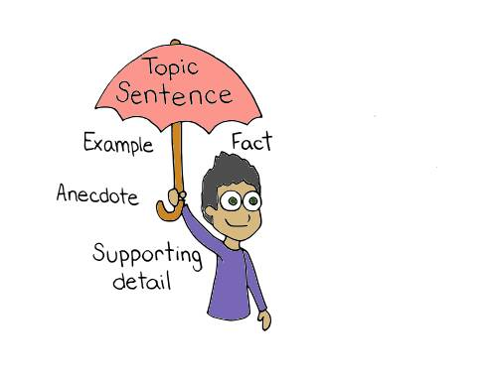

**Topic Sentences:**

A **topic sentence** is the main idea of a paragraph. It's the most general statement in the paragraph, and all other sentences serve to support, explain, or prove it. Think of it as a mini-thesis for a single paragraph.

A **supporting sentence** provides the details, evidence, and explanations that flesh out the topic sentence. They offer specific facts, examples, statistics, or reasons to validate the paragraph's main point. Without supporting sentences, a topic sentence would be an unproven claim.

## **Making an Effective Topic Sentence**

Here are some pointers to make a topic sentence effective:

* **Be a complete sentence:** A topic sentence needs a subject and a verb. A phrase or a single word isn't enough.
* **Be a clear and focused statement:** A good topic sentence is specific enough to be manageable within a single paragraph but not so narrow that it leaves nothing to discuss. Avoid broad, sweeping generalizations.
* **Introduce a single idea:** A paragraph should focus on one central point. An effective topic sentence introduces that one idea, and the supporting sentences should all relate back to it.
* **Be arguable or provable:** The best topic sentences are ones that you can support with evidence. They are not simple, undeniable facts. For example, "The sky is blue" is not a good topic sentence because it's a statement of fact that can't be elaborated on. A better one would be, "The unique atmospheric conditions on Mars create spectacular sunsets."
* **Usually placed at the beginning:** While not a strict rule, the topic sentence is most often the first sentence of a paragraph. This placement helps the reader immediately understand the paragraph's purpose and direction.

## **Example Paragraph**

Let's look at an example paragraph with its parts highlighted:

**[Topic Sentence]** The discovery of penicillin revolutionized medicine and saved countless lives. **[Supporting Sentence]** Before its development, a simple bacterial infection could be a death sentence, with no effective treatments available. **[Supporting Sentence]** Alexander Fleming's observation of mold inhibiting bacterial growth led to the isolation of this powerful antibiotic.9 **[Supporting Sentence]** Penicillin's ability to combat diseases like pneumonia, syphilis, and scarlet fever dramatically reduced mortality rates around the world. **[Concluding Sentence]** As a result, its widespread use marked the beginning of the antibiotic era and fundamentally changed the course of medical history.

**Vocabulary and Grammar**

**A. Synonyms and Antonyms:**

Replace the given words with their appropriate synonyms:

i. "paramount importance"

*a. Supreme significance*

b. irrelevance

c. low priority

ii. "compassion":

a. passion

*b. empathy*

c. compulsory

iii. "harmonious coexistence":

a. musical existence

*b. peaceful existence*

c. harmful existence

iv. "sentient beings":

a.satisfied

b. stationary

*c. Feeling organisms*

v. "unnecessary suffering":

*a.avoidable pain*

b. needed distress

c. obligatory suffering

**B. Identify antonyms of the given words:**

i. "acknowledging":

*a. Neglecting*

b. Embracing

c. Appreciating

ii. "compassion":

*a. Indifference*

b. Sympathy

c. Empathy

iii. "essential":

*a. Dispensable*

b. Significant

c. Vital

iv. "intricately linked":

*a. Disconnected*

b. Unified

c. Interconnected

v. Find an antonym for "profound":

*a. Superficial*

b. Deep

c. Intense

**Nouns**

Nouns can be categorized in several ways, and one of the most fundamental distinctions is between **concrete nouns** and **abstract nouns**. This classification is based on whether the noun refers to something that can be perceived with the five senses.

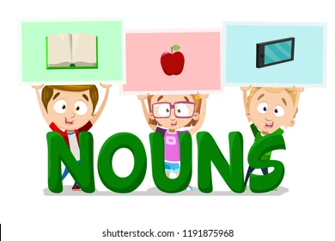

### **Concrete Nouns**

A **concrete noun** refers to a person, place, or thing that exists physically in the world and can be experienced by at least one of the five senses (sight, sound, smell, taste, or touch).3 Most nouns we use daily are concrete nouns.

* **People:** *teacher, Michael, doctor, crowd*
* **Places:** *city, school, Paris, backyard*
* **Things:** *table, book, car, hamburger*

Even things that can't be touched but can be sensed, like **air** (felt) or **music** (heard), are considered concrete nouns. Similarly, imaginary or fictional things that have a physical form, like a **dragon** or **Santa Claus**, are also classified as concrete nouns because they are described as tangible beings.

### **Abstract Nouns**

An **abstract noun** refers to a concept, quality, or idea that is intangible and cannot be perceived by the five senses. They exist only in our minds as thoughts or feelings.

* **Emotions:** *happiness, anger, fear, love*
* **Qualities:** *bravery, honesty, intelligence, kindness*
* **Concepts/Ideas:** *freedom, justice, democracy, success*
* **States of Being:** *childhood, poverty, chaos14*

It's important to note that while you can't see or touch "happiness," you can observe its **concrete** manifestations, such as a **smile** or **laughter**. This is a key distinction.

### **Examples in Sentences**

Here's a breakdown of concrete and abstract nouns in a few sentences:

1. "The **dog** chased the **ball** with **joy**."
   * **Concrete:** *dog, ball* (You can see and touch them.)
   * **Abstract:** *joy* (An emotion that cannot be physically sensed.)
2. "His **bravery** was a source of **inspiration** for the entire **team**."
   * **Abstract:** *bravery, inspiration* (Intangible qualities.)
   * **Concrete:** *team* (A group of people you can see.)

The distinction helps writers to either ground their descriptions in sensory details (using concrete nouns) or to discuss complex, non-physical concepts (using abstract nouns).

The distinction between these types of nouns is discussed in this YouTube video.

**Q: Identify six abstract and six concrete nouns from the given passage:**

Love is like a cozy blanket, wrapping us in warmth. Intelligence is like a bright bulb, guiding us through darkness. Loyalty is a sturdy bridge, connecting hearts. Peace is a beautiful flower, adding to the beauty of the world. Together, they form a beautiful harmony that everyone deserves to experience.

**Ans. Abstract Nouns (ideas, qualities, or concepts — not physical things):**

1. Love
2. Intelligence
3. Loyalty
4. Peace
5. Beauty
6. Harmony

### **Concrete Nouns (physical objects — can be seen, touched, or felt):**

1. Blanket
2. Warmth
3. Bulb
4. Bridge
5. Hearts
6. Flower

**Noun Phrase**

A **noun phrase** is a group of words that functions as a single noun in a sentence.1 It's built around a central noun, known as the head noun, and it can be as simple as a single word or a complex group of words that modifies the head noun.2 The primary function of a noun phrase is to name a person, place, thing, or idea.

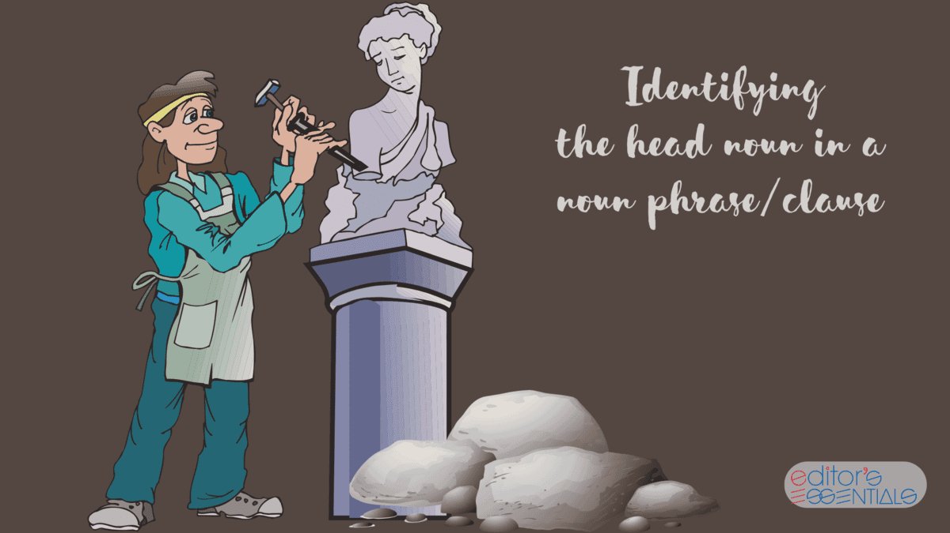

### **Components of a Noun Phrase**

A noun phrase can have various components that provide more detail about the head noun.3 These components can include determiners, adjectives, and other phrases.4

#### **i. A noun, a conjunction, and a noun**

This type of noun phrase combines two nouns with a conjunction (such as "and", "or", "but") to form a single unit. It acts as the subject or object of a sentence.5

* *The* ***book and the pen*** *are on the table.*6
* *He gave the* ***dog and the cat*** *a treat.*

#### **ii. A gerund and a noun**

A **gerund** is a verb form ending in "-ing" that functions as a noun.7 When a gerund is followed by a noun, they can form a noun phrase.8

* ***Swimming laps*** *is great exercise.*9
* *He enjoys* ***reading books****.*

#### **iii. An article, an adjective, and a noun**

This is a very common structure where an **article** (a, an, the) and an **adjective** modify the head noun. The article specifies the noun, while the adjective describes it.

* *The* ***tall building*** *is a landmark.*
* *She found* ***a shiny coin****.*

#### **iv. An article, a noun, and a prepositional phrase10**

In this structure, a **prepositional phrase** (a phrase beginning with a preposition like "of," "in," or "with") modifies the head noun by providing more specific information about it.11

* *The* ***house on the hill*** *is very old.*
* *He held* ***the key to the box****.*

#### **v. A determiner and a noun**

A **determiner** is a word that introduces a noun and provides context, such as quantity or possession.12 This is one of the simplest forms of a noun phrase.

* ***My car*** *is parked outside.*13
* ***That dog*** *is friendly.*
* ***Three students*** *arrived late.*

**Q. Identify the noun phrases from the sentences given below.**

i. Have you ever visited Paris or Spain?

ii. Tahir and Anum are my cousins.

iii. Did you find the two-storeyed building on the fifth street?

iv. Pasta and cake seem to be my sister's newly-found favourite food.

v. Neha helped her sister in finding the missing word in the puzzle.

vi. Did you find the answer to the question?

vii. Those shoes are torn; I don't think I can use them anymore.

viii. Asim and Sonia will be moving to Germany next year.

ix. Shaan was not able to finish the box of chocolate

x. Do you know who was looking for this bag?

Ans. **i. Paris, Spain  
 ii. Tahir, Anum, my cousins  
 iii. the two-storeyed building on the fifth street  
 iv. Pasta, cake, my sister's newly-found favourite food  
 v. Neha, her sister, the missing word, the puzzle  
 vi. the answer to the question  
 vii. Those shoes  
 viii. Asim, Sonia, Germany  
 ix. Shaan, the box of chocolate  
 x. this bag**

**Past Indefinite Tense**

The **Past Indefinite Tense**, also known as the Simple Past Tense, is used to describe actions or states that happened at a specific point in the past and are now finished. It is one of the most common tenses in English. The key feature of this tense is that the action is not ongoing; it is completed.

### **Formation**

The structure of the Past Indefinite Tense is straightforward: Subject + Verb in the Past Simple form. The main challenge lies in knowing whether the verb is regular or irregular.

#### **Regular Verbs**

For **regular verbs**, you simply add **-ed** to the base form of the verb.

* **Subject + Base Verb + -ed**
* **Walk** 4→ **walked5**
  + *I walked to the store.*6
* **Play** 7→ **played8**
  + *They played soccer yesterday.*9
* **Talk** 10→ **talked11**
  + *We talked on the phone last night.*12
* **Study** 13→ **studied** (Note: verbs ending in a consonant + 'y' change 'y' to 'i' before adding '-ed')14
  + *He studied for the exam.*15

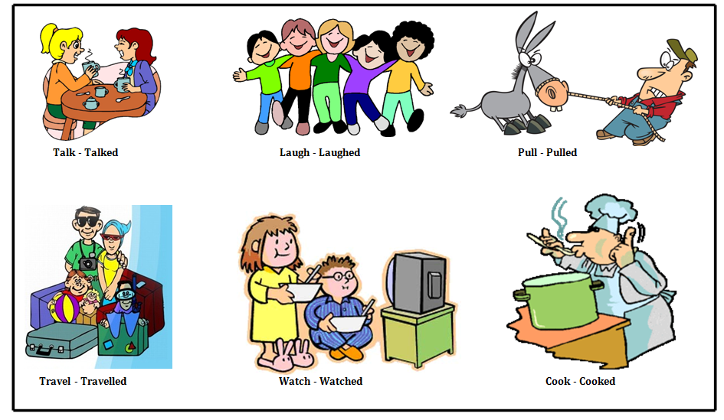**Irregular Verbs**For **irregular verbs**, the past tense form does not follow a predictable pattern.16 These forms must be memorized.

* **Subject + Irregular Past Tense Verb**
* **Go** 17→ **went18**
  + *She went to the park.*
* **Eat** 19→ **ate20**
  + *I ate a hamburger for lunch.*
* **See** 21→ **saw22**
  + *They saw the movie.*23
* **Run** 24→ **ran25**
  + *He ran a marathon.*26

### 

### **Forming Questions and Negatives**

For questions and negative statements, the auxiliary verb **did** is used. The main verb then reverts to its base form.

#### **Questions**

The structure is: **Did + Subject + Base Verb?**

* *Did you* ***eat*** *breakfast?* (Not: "Did you ate breakfast?")
* *Did she* ***go*** *to the party?*27

#### **Negative Statements**

The structure is: **Subject + did not (didn't) + Base Verb.**

* *I did not* ***see*** *him.* (Not: "I did not saw him.")
* *They didn't* ***finish*** *their homework.*28

### **Common Uses of Past Indefinite Tense**

1. **Completed actions in the past:**
   * *I* ***lived*** *in New York for two years.* (The action of living there is over.)29
2. **A series of completed actions in the past:**
   * *He* ***woke up****,* ***got dressed****, and* ***left*** *for work.*30
3. **Past habits or routines:**
   * *We often* ***visited*** *our grandparents in the summer.*
4. **Stories or narratives in the past:**
   * *Once upon a time, a king* ***ruled*** *a great kingdom.*

**Read the following passage and note the verbs:**

"The sun is shining brightly, and birds are singing in the trees. Sarah walks to the market and buys fresh vegetables for dinner. Later, she meets her friends at the cafe, and they talk for hours. In the evening, she watches a movie and goes to bed."

**Change the verbs into the Past Indefinite Tense.**

**Ans.** "The sun **shone** brightly, and birds **sang** in the trees. Sarah **walked** to the market and **bought** fresh vegetables for dinner. Later, she **met** her friends at the cafe, and they **talked** for hours. In the evening, she **watched** a movie and **went** to bed."

**Past Continuous Tense**

The **Past Continuous Tense** (also known as the Past Progressive Tense) is used to describe an action that was ongoing or in progress at a specific time in the past.1 It describes what was happening around a particular moment.

### **Structure**

The structure of the Past Continuous Tense is formed with the past tense of the verb "to be" (2was or 3were) and the present participle of the main verb (base verb + -ing).4

**Subject + was/were + Verb (-ing)**

* **was** is used for singular subjects (I,he,she,it).
* **were** is used for plural subjects (we,you,they).

**Examples:**

* *I* ***was reading*** *a book.*
* *She* ***was studying*** *for her test.*
* *They* ***were playing*** *soccer.*
* *The birds* ***were singing*** *in the trees.*

### **When to Use It**

The Past Continuous Tense is used in several key situations to provide context and detail about past events.

#### **1. To describe an action interrupted by another action5**

This is a very common use. The ongoing action (in Past Continuous) is interrupted by a shorter, completed action (in Simple Past).

* *I* ***was walking*** *to the store when I* ***saw*** *my friend.*6
* *She* ***was cooking*** *dinner when the phone* ***rang****.*

#### **2. To describe a specific time as an interruption**

The Past Continuous is used to show what was happening at a particular point in time.7 The specific time acts as the interruption.8

* *At 8 p.m. last night, I* ***was watching*** *a movie.*9
* *What* ***were you doing*** *at midnight?*

#### **3. To describe two parallel actions happening at the same time10**

This use shows two or more actions that were in progress simultaneously.11

* *While I* ***was doing*** *my homework, my brother* ***was watching*** *TV.*12
* *He* ***was listening*** *to music while he* ***was jogging****.*

#### **4. To set the scene in a story or narrative13**

The Past Continuous can be used at the beginning of a story or paragraph to describe the background or atmosphere.14

* *The sun* ***was shining*** *and the birds* ***were singing*** *as she walked through the park.*
* *It* ***was raining*** *heavily, and the wind* ***was howling****.*

**Read the passage below and fill in the blanks with the appropriate form of the verbs in the past continuous tense.**

Last night, while I _________ (cook) dinner, my friends _________ (play) board games in the living room. The rain _________ (pour) outside, and thunder _________ (rumble) in the distance. Suddenly, the lights went out, and we _________ (use) candles for the rest of the evening. As I _________ (prepare) the meal, my friends _________ (tell) funny stories, and we all _________ (laugh) together.

**Ans.** Last night, while I **was cooking** dinner, my friends **were playing** board games in the living room. The rain **was pouring** outside, and thunder **was rumbling** in the distance. Suddenly, the lights went out, and we **were using** candles for the rest of the evening. As I **was preparing** the meal, my friends **were telling** funny stories, and we all **were laughing** together.

### **Essay Writing**

An **essay** is a structured piece of writing that presents an argument, analysis, or explanation on a particular topic. It's an organized composition that typically includes an introduction (with a thesis statement), body paragraphs (each with a topic sentence and supporting evidence), and a conclusion. The main goal of an essay is to persuade the reader, provide a detailed analysis, or present a cohesive argument based on research, facts, and logical reasoning.



### **Summary Writing**

A **summary** is a concise and objective overview of the main points of a text. It condenses the original material into a shorter form, highlighting the most important ideas while leaving out minor details, examples, and repetitions. The purpose of a summary is to provide a quick understanding of the source text's core message without misrepresenting the author's original intent. A good summary is always written in your own words.



#### **How to Write a Summary**

1. **Read and Understand the Original Text:** Read the text at least twice. The first time, read for a general understanding. The second time, read more carefully to identify the main idea and key supporting points.
2. **Identify the Main Idea and Key Points:** Ask yourself:
   * What is the central topic of the text?
   * What are the most important arguments or pieces of information the author provides?
   * What is the author's purpose for writing this?
3. **Draft the Summary:**
   * Start by stating the main idea in a single sentence.
   * In the following sentences, briefly explain the key supporting points you identified.
   * Use your own words as much as possible. Do not copy sentences or phrases directly from the original text.
   * Maintain a neutral, objective tone. Do not include your personal opinions, interpretations, or new information.
4. **Review and Refine:**
   * Read your summary to ensure it's coherent and flows logically.
   * Check that it accurately reflects the original text's meaning.
   * Make sure it is significantly shorter than the source text—typically, a summary is about one-fourth the length of the original.

